07:19
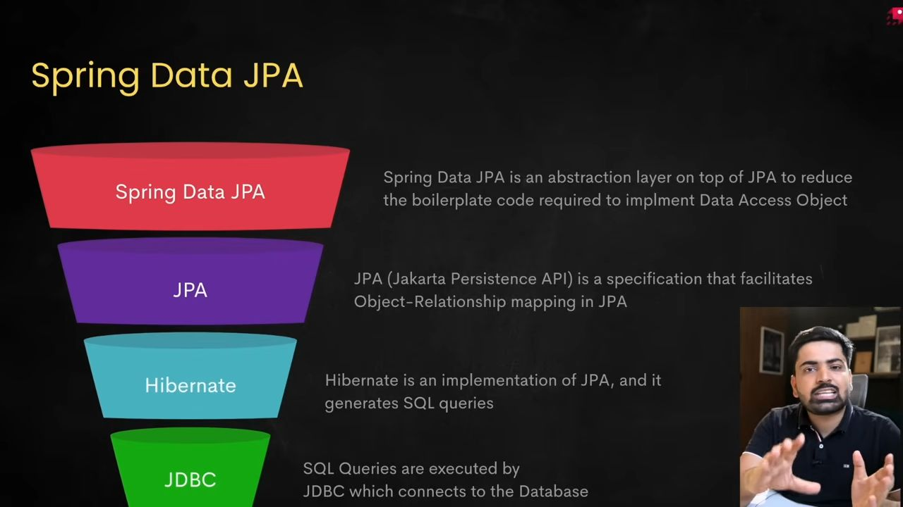
JPQL query language for custom queries.
The property spring.jpa.hibernate.ddl-auto in Spring Boot tells Hibernate how it should handle database schema (tables, columns, constraints, etc.) creation and updates automatically when your application starts.

Common values you can give:
- none
- Meaning: Hibernate will not touch the database schema at all.
- When to use: In production (safe choice) if you want to manage the schema manually with migrations (e.g., Flyway, Liquibase).
- validate
- Meaning: Hibernate will only validate that the entities in your code match the schema in the database. If they don’t match, it throws an error.
- When to use: In production where you want to make sure your schema matches your code but not let Hibernate change it.
- update
- Meaning: Hibernate will try to update the schema automatically (add new tables, columns, constraints) without dropping existing data.
- When to use: During development, to avoid running SQL manually when you add fields or entities. ⚠️ Risky in production, because Hibernate might alter things unexpectedly.
- create
- Meaning: Hibernate will drop the existing schema and create a new one every time the application starts.
- When to use: For testing or quick prototyping. Not safe for production since data will be lost each restart.
- create-drop
- Meaning: Same as create, but Hibernate will also drop the schema when the application stops.
- When to use: Useful for unit tests or short-lived demo applications.
- drop (rare, legacy option)
- Meaning: Drops the schema without recreating.
- When to use: Almost never.
@Entity → Marks class as a DB table.
@Id → Marks field as primary key.
@GeneratedValue(strategy = GenerationType.IDENTITY) → Lets DB auto-increment the ID.

Other strategies (for understanding):
- AUTO (default) → Hibernate chooses automatically based on DB.
- SEQUENCE → Uses a database sequence (common in Oracle/Postgres).
- TABLE → Uses a special table to generate IDs (rarely used).
40:28
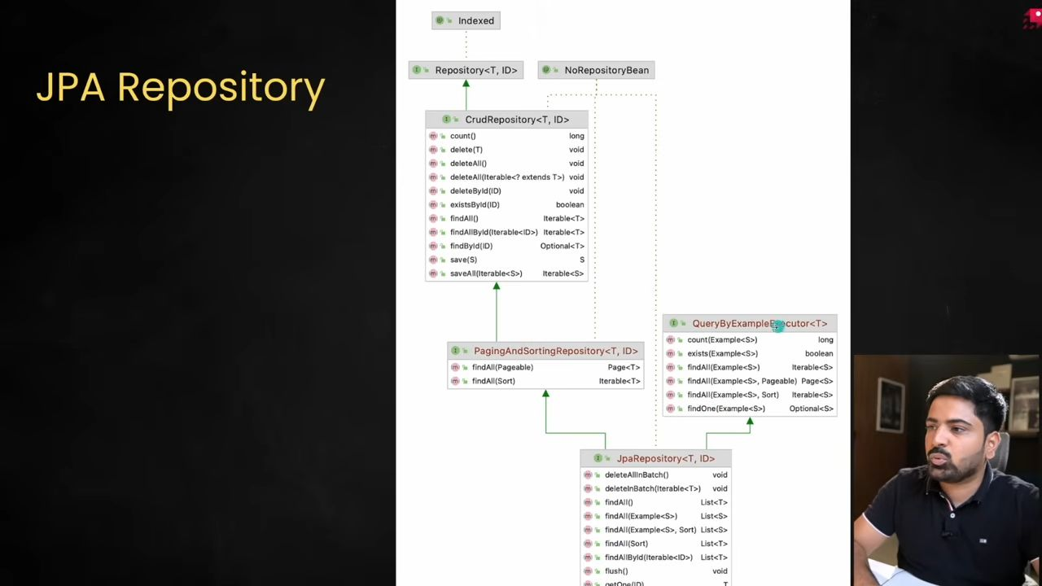All these methods of the interfaces are at the end written in a concrete class named as SimpleJpaRepository
42:32
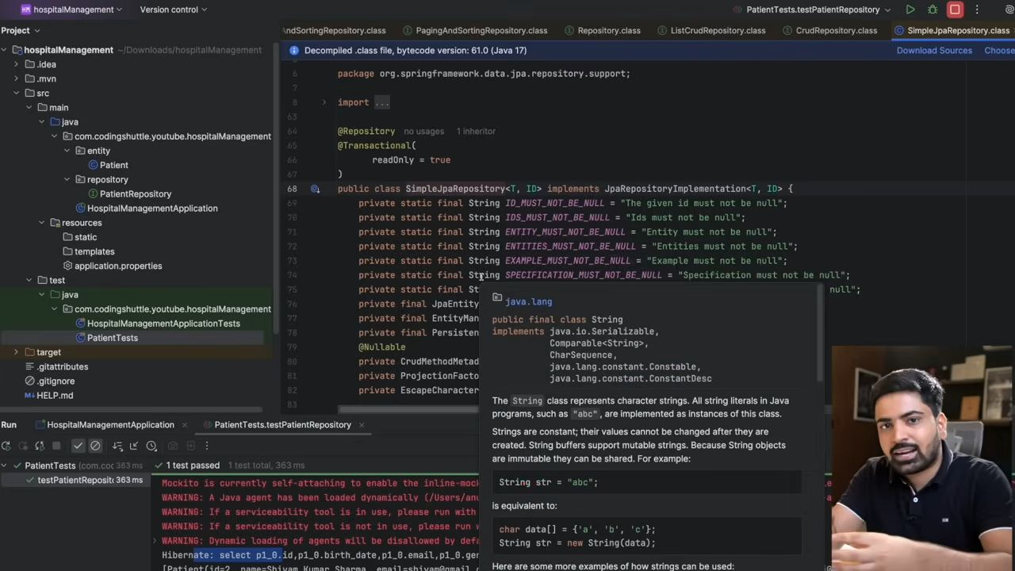This class uses something which is called as EntityManager.

Hibernate - Entity Lifecycle
47:32
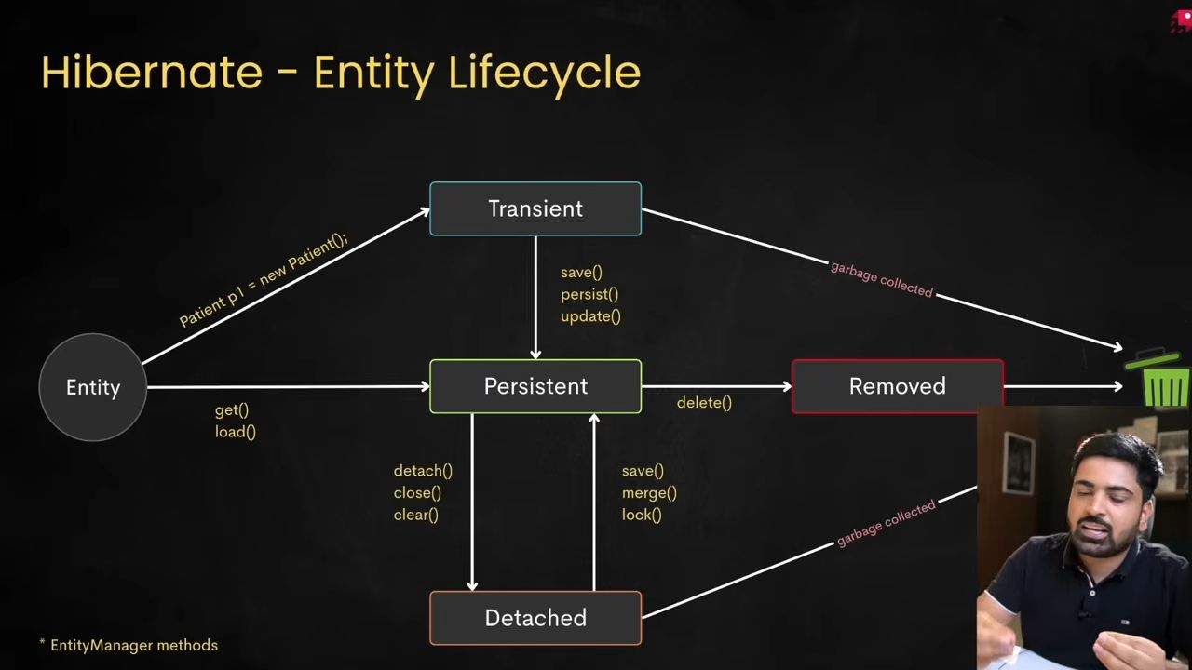
Perfect 👌 This is an important Spring Boot + Hibernate concept. Let me explain the Hibernate Entity Lifecycle in very simple terms with an example.

Hibernate Entity Lifecycle States
Hibernate manages entities (objects mapped to database rows) through 4 main states:

1. Transient State
- An object is created using new but not associated with Hibernate’s Session.
- It does not exist in the database yet.
- Hibernate does not track it.
Example:
User user = new User(); // new object in memory
user.setName("Rohit");
👉 Right now, this user is Transient. If the program ends, this object is lost.

2. Persistent State
- When you call session.save() or entityManager.persist(), Hibernate starts managing the object.
- The entity is now linked to a database row.
- Any changes you make are automatically tracked and will be saved in the database when the transaction commits.
Example:
Session session = sessionFactory.openSession();
session.beginTransaction();
session.save(user); // user is now Persistent
user.setEmail("rohit@example.com"); // Hibernate notices this change
session.getTransaction().commit();
👉 Hibernate will insert a new row for user and also update the email because the object was modified while persistent.

3. Detached State
- After the session is closed, the object still exists in memory but is not managed by Hibernate anymore.
- Changes you make now are not tracked.
Example:
session.close(); // session ends
user.setName("Rohit Joshi"); // Hibernate won’t update this change
👉 The object is still in Java memory, but the DB doesn’t know about this update.

4. Removed State
- If you delete an entity using session.delete() or entityManager.remove(), it becomes Removed.
- The row will be deleted from the database when the transaction commits.
Example:
Session session2 = sessionFactory.openSession();
session2.beginTransaction();
session2.delete(user); // user is now in Removed state
session2.getTransaction().commit();
👉 The corresponding row is deleted from the database.

🔁 Summary of States
State Managed by Hibernate? Stored in DB? Example Transient ❌ No ❌ No new User() Persistent ✅ Yes ✅ Yes (after commit) session.save(user) Detached ❌ No ✅ Yes Object after session.close() Removed ✅ Yes (until commit) ❌ No (after commit) session.delete(user)

Full Example Flow:
// 1. Transient
User user = new User();
user.setName("Rohit");
// 2. Persistent
Session session = sessionFactory.openSession();
session.beginTransaction();
session.save(user); // Persistent
user.setEmail("rohit@example.com"); // tracked by Hibernate
session.getTransaction().commit(); // INSERT + UPDATE executed
// 3. Detached
session.close();
user.setName("Detached Name"); // not tracked
// 4. Removed
Session newSession = sessionFactory.openSession();
newSession.beginTransaction();
newSession.delete(user); // Removed
newSession.getTransaction().commit(); // DELETE executed
✅ In short:
- Transient = new object, not in DB.
- Persistent = managed by Hibernate, changes auto-saved.
- Detached = exists in memory, but Hibernate doesn’t track changes.
- Removed = marked for deletion.
49:32
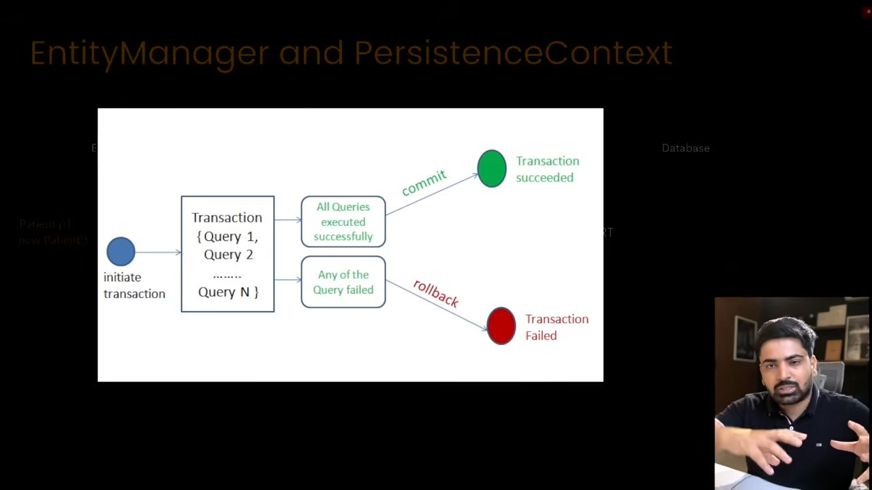
50:14
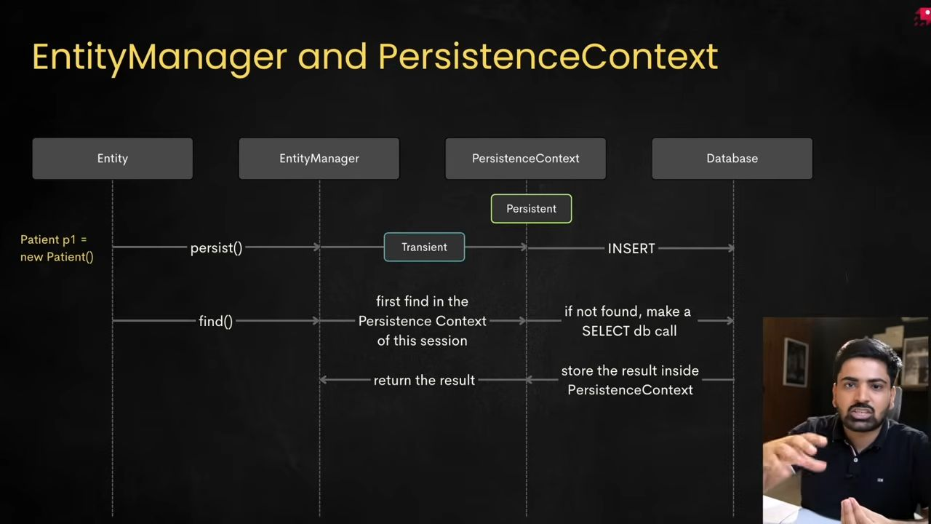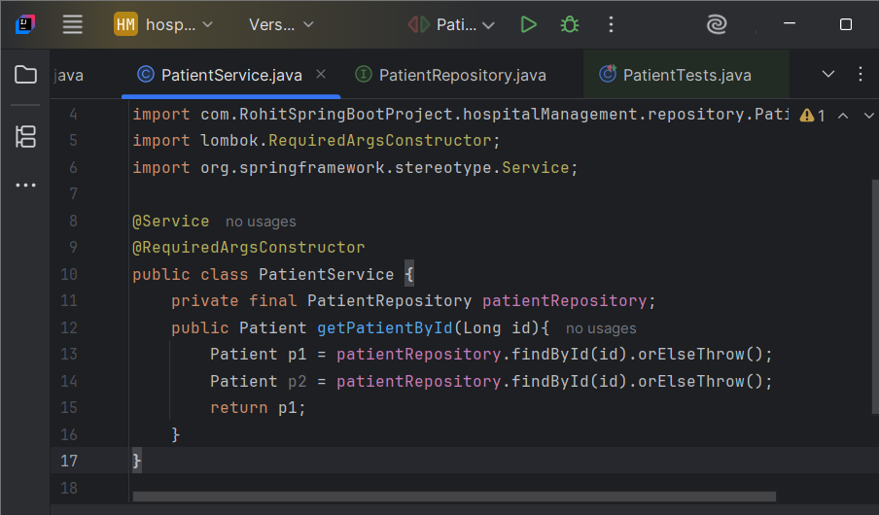
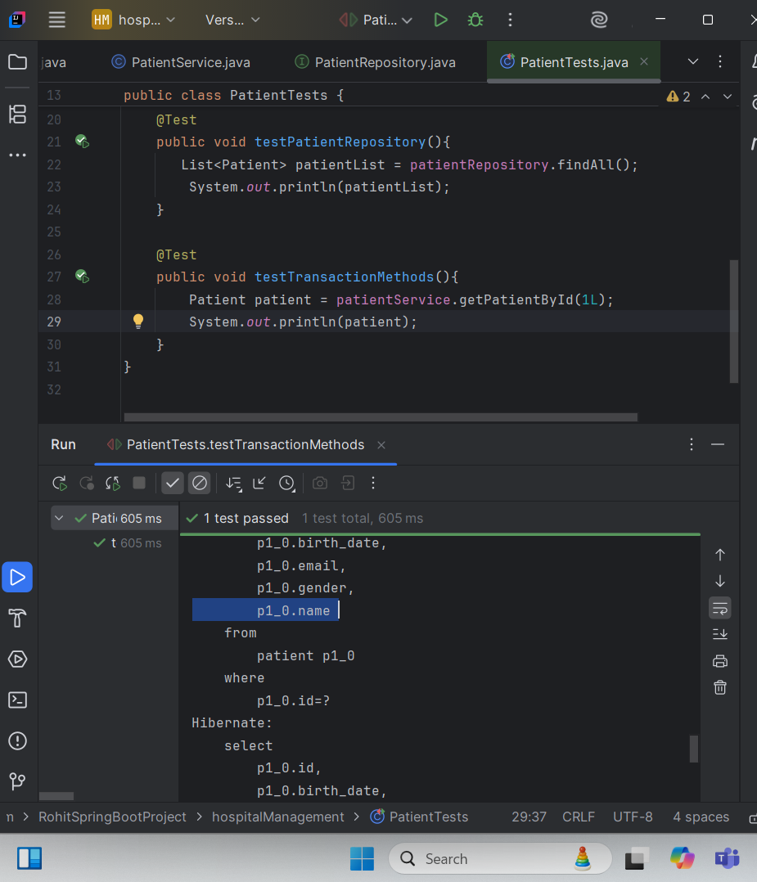Here, when we run the testTransactionMethod() then I am getting 2 queries, yani ye method 2 baar run hua hai. Yaha pe har ek method apni transaction banata hai and khtm ho jata hai. We are not maintaining any transaction here.
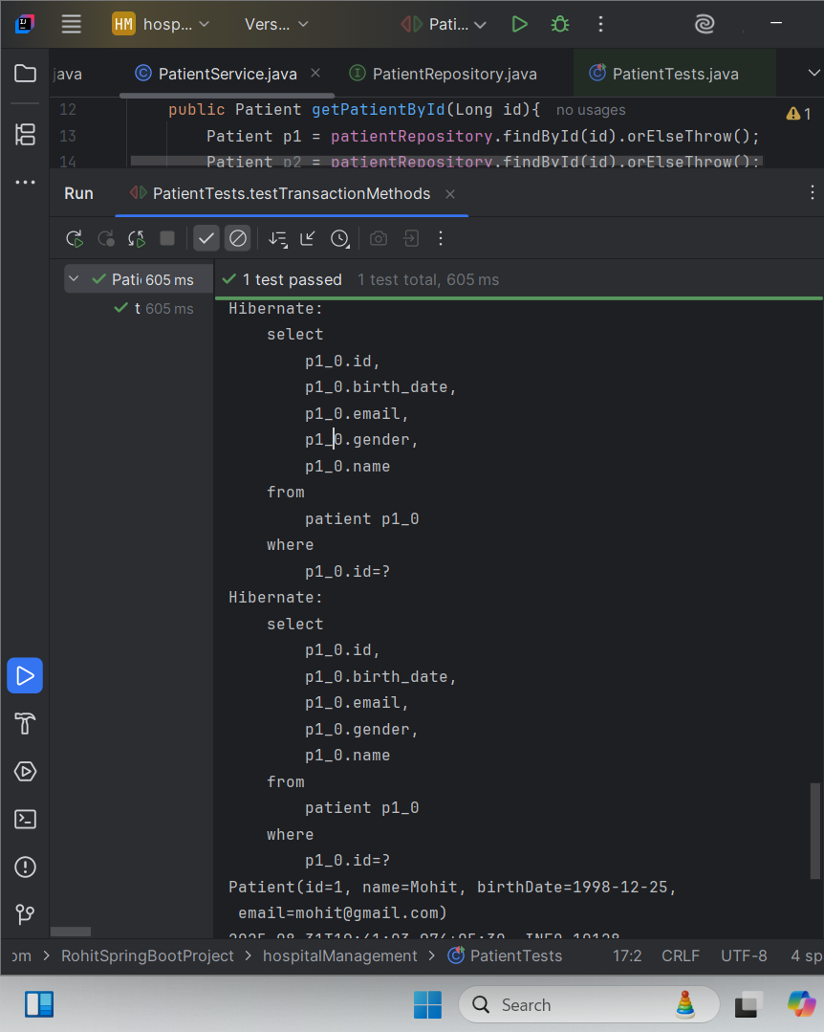This is happening as we are not managing any transactions.
But what if you make this method a transaction method?
54:20
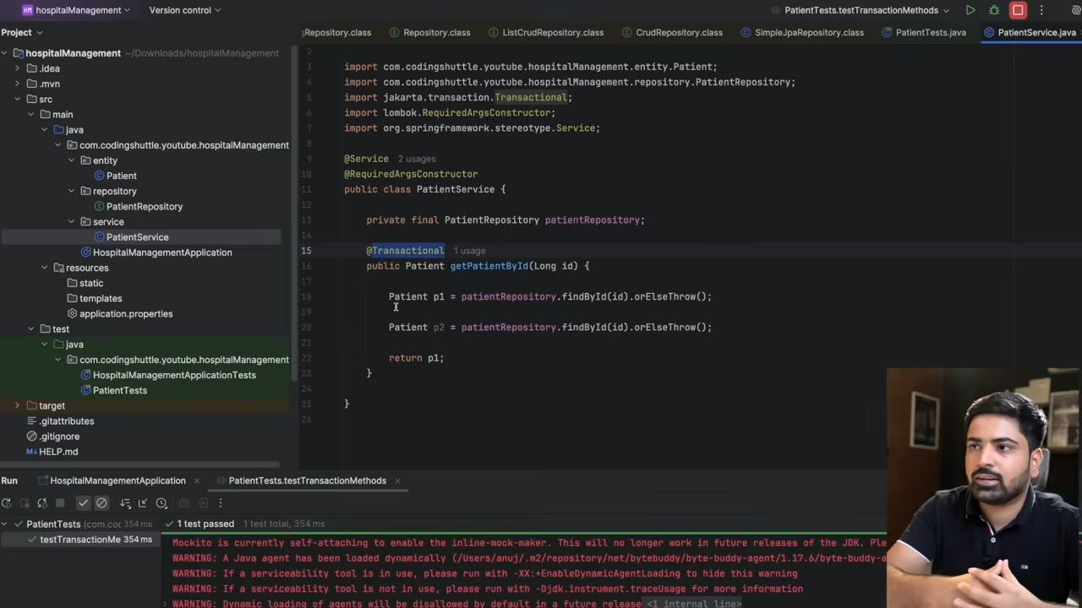
54:58
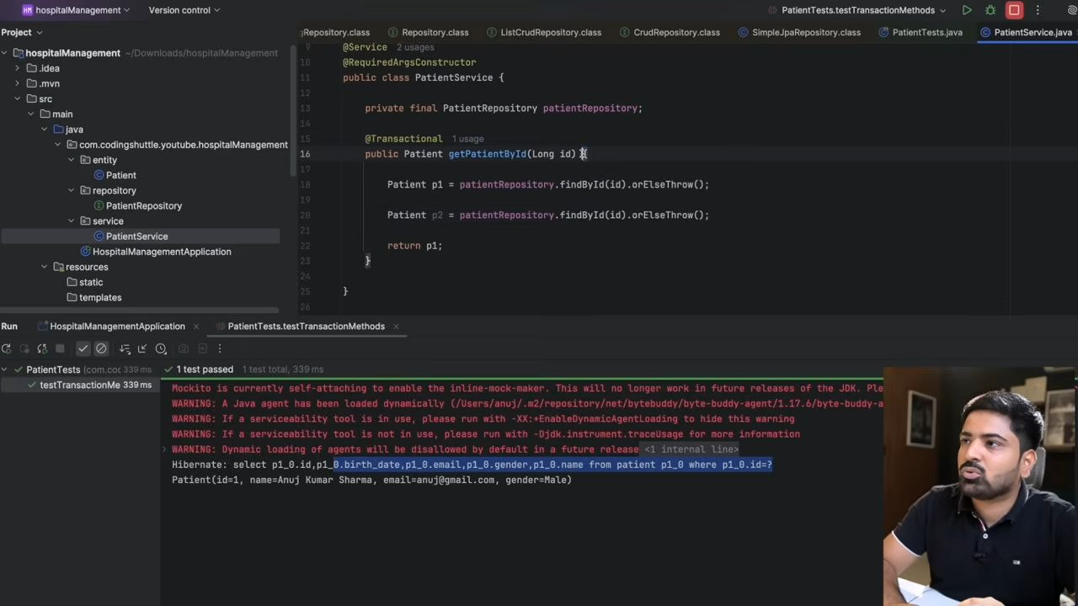
Ye ek baar aya kyuki ye sara ka sara data persistent context k ander jayega. P1 and P2 dono same jagha ko refere kr rhe hai
56:11
57:57
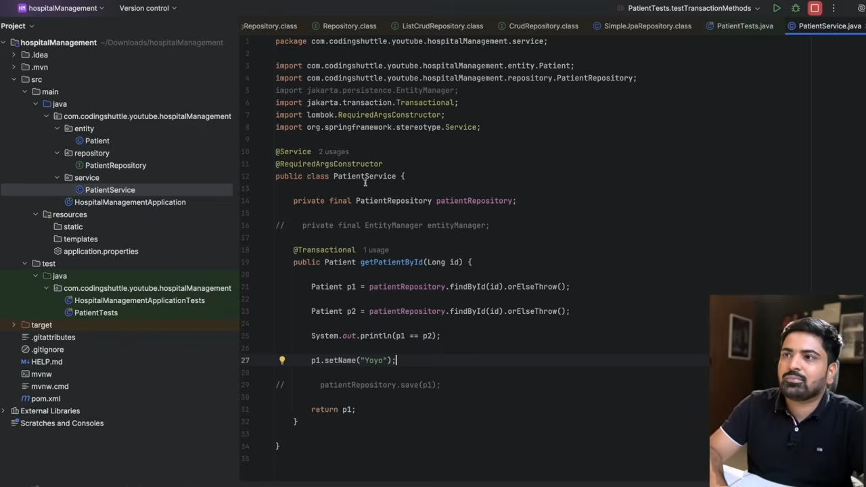
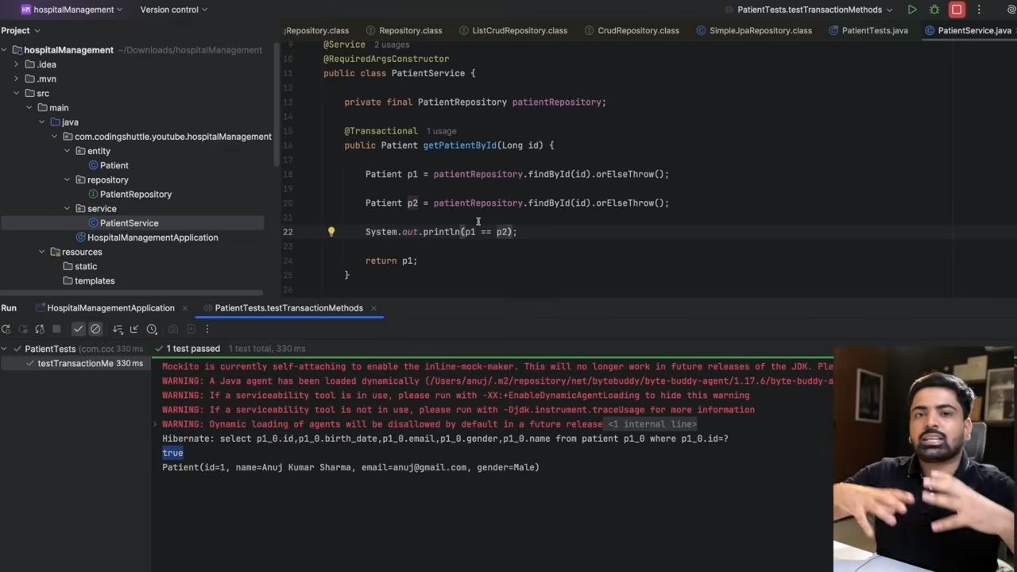Ye bina save ki call ho jayea and update bhi ho jayega. p1.setName("Yoyo") iska transactional context ban chuka hai. And jab ye commit hoga toh dirty checking hogi. Ye bhai, maine kuch change kiya hi nahi tha. iske ander and agr kia tha toh update call apne aap ho jayegi.
Let me explain @Transactional in Spring Boot in simple terms.

🔹 What is @Transactional in Spring Boot?
In Spring Boot (and Spring Framework), @Transactional is used to manage database transactions automatically.
A transaction means a unit of work where either:
- All operations succeed → changes are saved (committed),
- Any operation fails → changes are undone (rolled back).
This ensures data consistency.

🔹 Example without @Transactional
Suppose you are transferring money between two bank accounts:
public void transferMoney(Long fromAcc, Long toAcc, double amount) {
debit(fromAcc, amount); // deduct money
credit(toAcc, amount); // add money
}
👉 If debit succeeds but credit fails, the money will be lost.
We don’t want that!

🔹 Using @Transactional
import org.springframework.stereotype.Service;
import org.springframework.transaction.annotation.Transactional;
@Service
public class BankService {
@Transactional public void transferMoney(Long fromAcc, Long toAcc, double amount) { debit(fromAcc, amount); // deduct money credit(toAcc, amount); // add money } private void debit(Long accId, double amount) { // deduct balance from account } private void credit(Long accId, double amount) { // add balance to account }
}
👉 Now, if credit() fails, Spring will rollback debit() automatically.
So the money will stay safe ✅

🔹 Important Points about @Transactional
- Default Behavior
- Commits the transaction if the method completes successfully.
- Rolls back the transaction if a RuntimeException occurs.
- Checked Exceptions
- By default, transactions do NOT rollback for checked exceptions.
- You can configure:
@Transactional(rollbackFor = Exception.class)
- Propagation
- Defines how transactions behave when methods call each other.
- Example: REQUIRED (default) → join the existing transaction, or create a new one if none exists.
- Isolation Levels
- Controls how concurrent transactions interact (e.g., READ_COMMITTED, SERIALIZABLE).

🔹 Simple Real-World Example
@Service
public class OrderService {
@Autowired private OrderRepository orderRepo; @Autowired private PaymentRepository paymentRepo; @Transactional public void placeOrder(Order order, Payment payment) { orderRepo.save(order); paymentRepo.save(payment); // if payment saving fails → order saving is rolled back automatically }
}
✅ In short:
@Transactional makes sure your database operations happen safely as a single unit of work – either everything is saved, or nothing is.
Perfect 👍 Let’s dive into the different propagation types of @Transactional in Spring Boot.

🔹 What is Propagation?
Propagation defines how a method with @Transactional behaves when it is called inside another transactional method.
Think of it like:
👉 “If a transaction already exists, should I join it or start a new one?”

🔹 Propagation Types in Spring

1. REQUIRED (Default)
- If a transaction exists → join it.
- If not → create a new one.
✅ Most commonly used.
@Transactional(propagation = Propagation.REQUIRED)
public void methodA() {
// joins existing transaction or creates new
}
Example:
- placeOrder() calls savePayment()
- Both run in the same transaction.
- If savePayment() fails → placeOrder() is rolled back too.

2. REQUIRES_NEW
- Always create a new transaction, even if one already exists.
- The existing transaction is paused until this finishes.
@Transactional(propagation = Propagation.REQUIRES_NEW)
public void methodB() {
// always starts a new transaction
}
Example:
- You save an Order.
- Then you log an Audit entry with REQUIRES_NEW.
- Even if the Order transaction fails, the Audit entry will still be committed.

3. NESTED
- Runs inside a nested transaction within the existing one.
- If nested transaction fails, only its changes are rolled back, not the parent.
- Requires database support for savepoints.
@Transactional(propagation = Propagation.NESTED)
public void methodC() {
// nested transaction
}
Example:
- placeOrder() has a nested call applyDiscount().
- If applyDiscount() fails, its changes are rolled back, but the main order still goes through.

4. MANDATORY
- Must run inside an existing transaction.
- If no transaction exists → throws exception.
@Transactional(propagation = Propagation.MANDATORY)
public void methodD() {
// requires a transaction, else exception
}
Example:
- You enforce that savePayment() can only be called inside a transaction.

5. NEVER
- Must not run inside a transaction.
- If a transaction exists → throws exception.
@Transactional(propagation = Propagation.NEVER)
public void methodE() {
// must run without transaction
}
Example:
- Used when you want to ensure a method runs outside of transactional context (e.g., just reading logs).

6. SUPPORTS
- If a transaction exists → join it.
- If not → run without transaction.
@Transactional(propagation = Propagation.SUPPORTS)
public void methodF() {
// works with or without a transaction
}
Example:
- Useful for read-only operations.
- Works fine with or without a transaction.

7. NOT_SUPPORTED
- Suspends an existing transaction and runs without one.
@Transactional(propagation = Propagation.NOT_SUPPORTED)
public void methodG() {
// runs without transaction
}
Example:
- You don’t want transaction overhead for a non-critical log operation.

🔹 Summary Table
Propagation Behavior REQUIRED Join existing or create new (default). REQUIRES_NEW Always create a new transaction. NESTED Run inside parent, rollback only itself if fails. MANDATORY Must run inside a transaction, else error. NEVER Must not run inside a transaction, else error. SUPPORTS Use transaction if exists, else run non-transactional. NOT_SUPPORTED Suspend transaction, run non-transactional.
✅ In real-world apps:
- Use REQUIRED for most cases.
- Use REQUIRES_NEW for logging, auditing, or sending notifications (so they commit even if main logic fails).
- Use NESTED when you want partial rollback inside a larger transaction.
Let’s now look at Isolation Levels in @Transactional.

🔹 What is Isolation Level?
When multiple transactions run at the same time, isolation controls how much they can “see” each other’s changes in the database.
👉 It prevents issues like:
- Dirty Read → reading uncommitted data
- Non-Repeatable Read → same query gives different results
- Phantom Read → new rows appear in the middle of a transaction

🔹 Types of Isolation Levels in Spring
Spring maps to database isolation levels (ANSI SQL standard):

1. DEFAULT
- Uses the database’s default isolation level.
- For PostgreSQL & MySQL → usually READ_COMMITTED.
@Transactional(isolation = Isolation.DEFAULT)
public void methodA() { }

2. READ_UNCOMMITTED
- Lowest isolation level.
- Transactions can read uncommitted (dirty) data from others.
- Faster, but unsafe.
👉 Problems: Dirty reads, non-repeatable reads, phantom reads.
@Transactional(isolation = Isolation.READ_UNCOMMITTED)
public void methodB() { }
Example:
- Tx1 updates balance but hasn’t committed.
- Tx2 reads that balance → later Tx1 rolls back → Tx2 read wrong data.

3. READ_COMMITTED
- Can only read data that is already committed.
- Prevents dirty reads, but allows non-repeatable reads and phantoms.
- Most common default.
@Transactional(isolation = Isolation.READ_COMMITTED)
public void methodC() { }
Example:
- Tx1 updates balance but not committed → Tx2 cannot see it.
- But if Tx1 commits later, Tx2 may see different results in the same transaction (non-repeatable).

4. REPEATABLE_READ
- Ensures that if you read the same row multiple times, you get the same result (even if another transaction updates it).
- Prevents dirty reads + non-repeatable reads.
- But phantom rows can appear (new rows from another transaction).
@Transactional(isolation = Isolation.REPEATABLE_READ)
public void methodD() { }
Example:
- Tx1 reads balance → Tx2 updates and commits → Tx1 reads again → still sees old value (repeatable).
- But if Tx2 inserts a new row matching Tx1’s query, Tx1 may see new rows (phantom).

5. SERIALIZABLE
- Highest isolation level.
- Transactions run as if sequential (one after another).
- Prevents dirty reads, non-repeatable reads, and phantom reads.
- Safest but slowest (lots of locking).
@Transactional(isolation = Isolation.SERIALIZABLE)
public void methodE() { }
Example:
- Tx1 and Tx2 cannot interfere at all → database may lock rows or even full tables to ensure strict consistency.

🔹 Summary Table
Isolation Level Dirty Reads Non-Repeatable Reads Phantom Reads Performance READ_UNCOMMITTED ✅ Allowed ✅ Allowed ✅ Allowed Fastest ⚡ READ_COMMITTED ❌ Prevented ✅ Allowed ✅ Allowed Common REPEATABLE_READ ❌ Prevented ❌ Prevented ✅ Allowed Slower SERIALIZABLE ❌ Prevented ❌ Prevented ❌ Prevented Slowest 🐢
✅ In real-world:
- Use READ_COMMITTED (default) → safe and good performance.
- Use REPEATABLE_READ for critical financial apps.
- Use SERIALIZABLE only if strict accuracy > performance.
Let’s build a real-world banking example combining both Propagation and Isolation levels.

🔹 Scenario: Bank Money Transfer
We have two operations:
- Transfer Money – deduct from one account and add to another.
- Save Audit Log – record the transaction in an audit table.

Problems to Handle:
- Both debit and credit must happen together (transactional unit).
- Audit logs should always be saved (even if transfer fails).
- Prevent dirty reads (don’t read uncommitted balances).

🔹 Code Example
import org.springframework.beans.factory.annotation.Autowired;
import org.springframework.stereotype.Service;
import org.springframework.transaction.annotation.Isolation;
import org.springframework.transaction.annotation.Propagation;
import org.springframework.transaction.annotation.Transactional;
@Service
public class BankService {
@Autowired private AccountRepository accountRepo; @Autowired private AuditService auditService; // Main transaction: Transfer money @Transactional( propagation = Propagation.REQUIRED, // join or create transaction isolation = Isolation.READ_COMMITTED // prevent dirty reads ) public void transfer(Long fromAcc, Long toAcc, double amount) { Account sender = accountRepo.findById(fromAcc).orElseThrow(); Account receiver = accountRepo.findById(toAcc).orElseThrow(); // deduct money if (sender.getBalance() < amount) { throw new RuntimeException("Insufficient balance!"); } sender.setBalance(sender.getBalance() - amount); receiver.setBalance(receiver.getBalance() + amount); accountRepo.save(sender); accountRepo.save(receiver); // save audit in a new transaction auditService.saveAudit(fromAcc, toAcc, amount); }
}

🔹 Audit Service with Different Propagation
import org.springframework.stereotype.Service;
import org.springframework.transaction.annotation.Propagation;
import org.springframework.transaction.annotation.Transactional;
@Service
public class AuditService {
@Autowired private AuditRepository auditRepo; // Always run in a new transaction @Transactional(propagation = Propagation.REQUIRES_NEW) public void saveAudit(Long fromAcc, Long toAcc, double amount) { Audit audit = new Audit(fromAcc, toAcc, amount, "TRANSFER INITIATED"); auditRepo.save(audit); }
}

🔹 What Happens in This Example?
- Propagation.REQUIRED on transfer()
- Ensures debit & credit happen inside one transaction.
- If debit fails → credit rolls back too.
- Isolation.READ_COMMITTED
- Prevents reading uncommitted balances.
- If another transaction is updating balance → wait until it commits.
- Propagation.REQUIRES_NEW on saveAudit()
- Creates a separate transaction for audit logs.
- Even if money transfer fails & rolls back, audit log is still saved (helps for debugging/audit trails).

🔹 Real-World Flow
✅ Case 1: Transfer succeeds
- Money deducted & credited → commit.
- Audit log saved in its own transaction.
✅ Case 2: Transfer fails (e.g., insufficient balance)
- Debit & credit rolled back.
- Audit log still saved (because of REQUIRES_NEW).
✅ Case 3: Two transfers at the same time
- Isolation READ_COMMITTED ensures no transaction can read half-updated balances.
👉 This setup is very common in banking, e-commerce payments, and financial systems.
Class mai jo hum naam dete hai and uska naam database mai dekhte hai toh wo camelCase(class) ko kabab case(Table) mai convert kr deta hai automatically.
Ex: class PatientTable ---> patient_table
To give you own name use @Table annotation.
Here’s a clean, practical breakdown of what that @Table is doing and the gotchas to be aware of.

What @Table means here
@Table(
name = "patient_tbl",
uniqueConstraints = {
@UniqueConstraint(name = "unique_patient_email", columnNames = {"email"}),
@UniqueConstraint(name = "unique_patient_name_birthdate", columnNames = {"name", "birthDate"})
},
indexes = {
@Index(name = "idx_patient_birth_date", columnList = "birthDate, email")
}
)

1) name = "patient_tbl"
- Tells JPA/Hibernate to map this entity to the patient_tbl table.
If you don’t set this, the table name is derived from the entity name and the active naming strategy (often patient → patient or patient → patient/patient_tbl depending on config).

2) uniqueConstraints = {...}

a) unique_patient_email on email
- Enforces one row per email (no duplicates).
- If email is nullable and you don’t set @Column(nullable = false), most DBs allow multiple NULLs even with a unique constraint.
- → If you truly want “unique-or-null-only-once”, make nullable=false or use a functional/partial unique index via migrations.

b) unique_patient_name_birthdate on (name, birthDate)
- A composite unique: the (name, birthDate) pair must be unique.
- This allows duplicate names or duplicate birth dates individually, but not the same pair twice.
Why name your constraints?
- The name = "unique_patient_email" is the database constraint name.
- Helpful when catching errors (Spring will throw DataIntegrityViolationException/ConstraintViolationException with that name); you can map it to a user-friendly message like: “Email already registered”.

3) indexes = {...}

idx_patient_birth_date on (birthDate, email)
- Creates a non-unique index to speed up reads.
- Column order matters (leftmost prefix rule):
- Good for queries like:
- WHERE birthDate = ?
- WHERE birthDate = ? AND email = ?
- WHERE birthDate BETWEEN ? AND ?
- Not helpful for WHERE email = ? alone. If you frequently search by email, add a separate index on email (you already get a unique index if you used a unique constraint, which many DBs implement as a unique index under the hood).

Example outcomes
Assume the columns are non-null and you already have:
Row1: (name="Rohit", birthDate=1999-01-01, email="rohit@x.com")
- ✅ Insert (name="Rohit", birthDate=1999-01-02, email="rohit2@x.com") — different pair and email.
- ❌ Insert (name="Rohit", birthDate=1999-01-01, email="other@x.com") — fails on unique_patient_name_birthdate.
- ❌ Insert (name="Someone", birthDate=2000-10-10, email="rohit@x.com") — fails on unique_patient_email.

Likely generated SQL (conceptual)
create table patient_tbl (
id bigint primary key,
name varchar(255) not null,
birth_date date not null,
email varchar(255) not null
-- other columns...
);
alter table patient_tbl
add constraint unique_patient_email unique (email);
alter table patient_tbl
add constraint unique_patient_name_birthdate unique (name, birth_date);
create index idx_patient_birth_date on patient_tbl (birth_date, email);
(Exact DDL varies by dialect.)

Important real-world notes & gotchas
- Naming strategy & column names
- You wrote columnNames = {"name", "birthDate"}.
- Hibernate’s physical naming strategy (Spring Boot’s default) often converts birthDate → birth_date. Hibernate will apply the same mapping to constraints/indexes.
- To avoid surprises, many teams prefer explicit @Column(name = "birth_date") and then use "birth_date" in constraints/indexes to be crystal clear.
- @Column(unique = true) vs @UniqueConstraint
- @Column(unique = true) is shorthand for single-column uniqueness, but you can’t name the constraint.
- @UniqueConstraint lets you name it and supports composite uniqueness. Prefer it for anything non-trivial.
- Nullability & uniqueness
- If email should be truly unique for all rows, add @Column(nullable = false) (and possibly validation).
- Otherwise you may get multiple NULL emails allowed by the DB.
- DDL generation vs migrations
- These annotations only affect schema if Hibernate is allowed to generate/update DDL (spring.jpa.hibernate.ddl-auto=create|update).
- In serious projects, use Flyway/Liquibase so changes are versioned. Keep the annotations for documentation + validation in dev.
- Case-insensitive uniqueness (emails)
- Many DBs (e.g., MySQL with default collation) treat text uniquely in a case-insensitive way; Postgres is case-sensitive by default.
- If you need case-insensitive unique email in Postgres, use a functional unique index on lower(email) via migration (JPA annotations don’t express functional indexes).
- Performance
- Unique constraints create/require an index; your extra non-unique index on (birthDate, email) targets read patterns.
- Don’t duplicate indexes unnecessarily (e.g., (email) unique and (email) non-unique).
- Catching violations
- On duplicate insert/update, Spring typically throws DataIntegrityViolationException.
- The constraint name you chose will appear in the message—perfect for mapping to helpful API errors.

Suggested best-practice entity snippet
@Entity
@Table(
name = "patient_tbl",
uniqueConstraints = {
@UniqueConstraint(name = "unique_patient_email", columnNames = {"email"}),
@UniqueConstraint(name = "unique_patient_name_birthdate", columnNames = {"name", "birth_date"})
},
indexes = {
@Index(name = "idx_patient_birth_date", columnList = "birth_date, email")
}
)
public class Patient {
@Id @GeneratedValue private Long id; @Column(name = "name", nullable = false, length = 150) private String name; @Column(name = "birth_date", nullable = false) private LocalDate birthDate; @Column(name = "email", nullable = false, length = 255) private String email; // getters/setters
}
Note how birthDate (Java field) is mapped to the DB column birth_date, and the same physical names are used in the constraints/indexes.Aah 👍 now I see what happened. When you changed your entity’s @Table(name = "patient_tbl"), Hibernate thought:👉 “Oh, this is a new table (different name from the old one), so I’ll create it if it doesn’t exist.”That’s why you now have two tables:patient (old one, with your data ✅)patient_tbl (new one, empty ❌)
And when you query through JPA, it looks in patient_tbl (because that’s what the entity points to), so nothing is found.

✅ How to rename a table but keep data
You have two options:

Option 1: Manually rename the table in the database
If you want to keep your existing data but switch to the new name (patient_tbl), just rename it in SQL:
For PostgreSQL / MySQL / most DBs:
ALTER TABLE patient RENAME TO patient_tbl;
Now the existing data will move into patient_tbl, and Hibernate will continue using it.
👉 This is the cleanest solution if you just want to rename.

Option 2: Point entity back to old table
If you don’t want to rename the actual database table, just make the entity point to the old table again:
@Table(name = "patient") // instead of patient_tbl
public class Patient { ... }
Now Hibernate will keep using your original table with data.

Option 3: Use Database Migration Tool (Best Practice ✅)
In real projects, we usually use Flyway or Liquibase to manage schema changes.
That way, you can keep data and apply controlled migrations.
Example Flyway migration script (V2__rename_patient_table.sql):
ALTER TABLE patient RENAME TO patient_tbl;
When you run the app, Flyway will automatically apply this change safely.

⚠️ Important: spring.jpa.hibernate.ddl-auto
Check what you have set in application.properties:
- create → drops & recreates tables each time (dangerous ❌ for real data).
- update → tries to update schema without dropping (safer for dev).
- validate → only validates, doesn’t change schema.
- none → does nothing, you manage schema yourself.
👉 If you want to keep data safe, don’t use create. Use update or better, manage schema with Flyway.
✅ So, in your case:
- If you want to keep old data and use new name → ALTER TABLE patient RENAME TO patient_tbl;
- If you want to keep using old table → change @Table(name = "patient")
Perfect 👍 Let’s set up Flyway in your Spring Boot project so that all schema changes (like renaming a table) are applied safely and your data is preserved.

🚀 Step 1: Add Flyway Dependency
If you’re using Maven, add this to your pom.xml:
<dependency>
<groupId>org.flywaydb</groupId>
<artifactId>flyway-core</artifactId>
</dependency>
If you’re using Gradle:
implementation 'org.flywaydb:flyway-core'
Spring Boot will automatically detect Flyway.

🚀 Step 2: Configure Flyway in application.properties
spring.flyway.enabled=true
spring.flyway.locations=classpath:db/migration
spring.jpa.hibernate.ddl-auto=validate
👉 Important:
- ddl-auto=validate means Hibernate will not create/alter tables automatically. Instead, Flyway will manage all changes.
- Migration scripts will be placed inside: src/main/resources/db/migration.

🚀 Step 3: Create a Migration Script
By convention, Flyway scripts are named:
V1__description.sql
V2__description.sql
V3__description.sql
...
For example, if you want to rename your patient table to patient_tbl, create this file:
📂 src/main/resources/db/migration/V2__rename_patient_table.sql
ALTER TABLE patient RENAME TO patient_tbl;
👉 Flyway will run this script automatically when your app starts.
👉 If the script is already applied once, Flyway will not run it again (safe!).

🚀 Step 4: Run and Verify
- Start your Spring Boot app.
- Flyway will detect any new migration scripts and apply them in order (V1, V2, …).
- Check your database → you should see patient_tbl with your old data.
Also, Flyway will create a special table in your DB called flyway_schema_history to track applied migrations.

🚀 Step 5: Best Practices
✅ Always write migrations for schema changes instead of letting Hibernate auto-generate.
✅ Never use ddl-auto=create in production (it wipes data!).
✅ Each migration file should handle one change (rename, add column, etc.).
✅ Use meaningful names:
- V1__init_schema.sql
- V2__rename_patient_table.sql
- V3__add_email_unique_constraint.sql
👉 So, with Flyway, if tomorrow you want to add a new column (say phone_number), you just create:
📂 src/main/resources/db/migration/V3__add_phone_number.sql
ALTER TABLE patient_tbl ADD COLUMN phone_number VARCHAR(20);
Flyway applies it safely ✅.

To run SQL directly from a file use this property and make a sql file in your resource folder.
spring.jpa.defer-datasource-initialization=true
spring.sql.init.mode=always
spring.sql.init.data-location=classpath:date.sql
